- Lab Title: Lab 1: Advanced SQL Injection Lab

- Assignment Title: Lab 1: Advanced SQL Injection Lab
- Student Name: Bashir Adam
- Student ID: 2025/FWSD/11509
- Course Name: BVWS103– OWASP-Top-10-Vulnerabilities-Exploitationentials
- Instructor Name: Aminu Idris
- Date of Submission: 23 JAN, 2026
- Version: Version 2.1.0

LAB OVERVIEW/OBJECTIVE

Objective:
This lab will cover advanced SQL injection techniques including:
- Error-based SQL injection
- Time-based Blind SQL injection
- Second-order SQL injection Students will exploit vulnerabilities in a web application, then apply mitigation strategies using secure coding practices.

Lab Requirements:
- Web Server: A local server setup such as XAMPP, WAMP, or LAMP (with PHP & MySQL).
- Database: A MySQL database with user authentication and product management.
- Basic Knowledge: Students should have a basic understanding of SQL, PHP, and SQL injection techniques.

Step 1: Setting up the Environment
I start by sating my XAMPP manually through the app

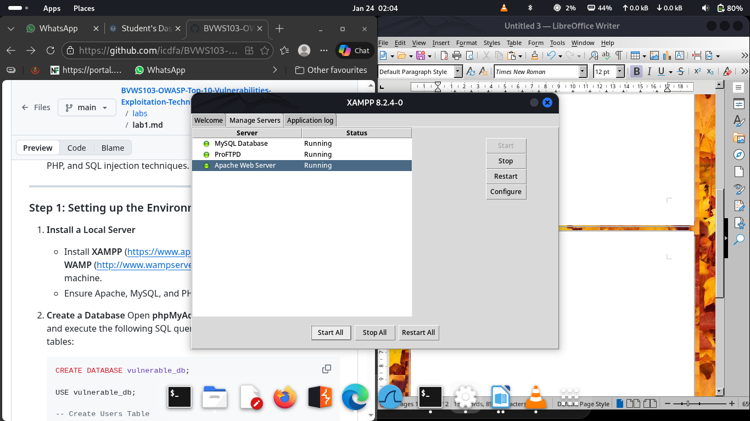

Then I verufy it through the terminal

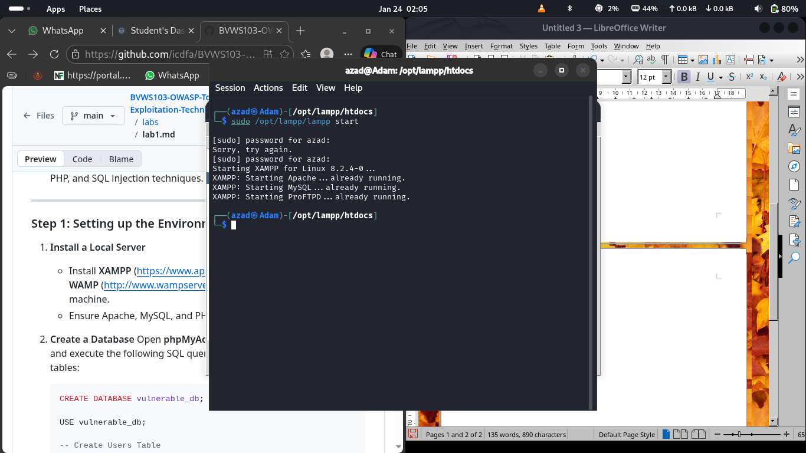

I Move directly ti my browser and navigate to “localhost/phpmyadmin” and the select the option SQL

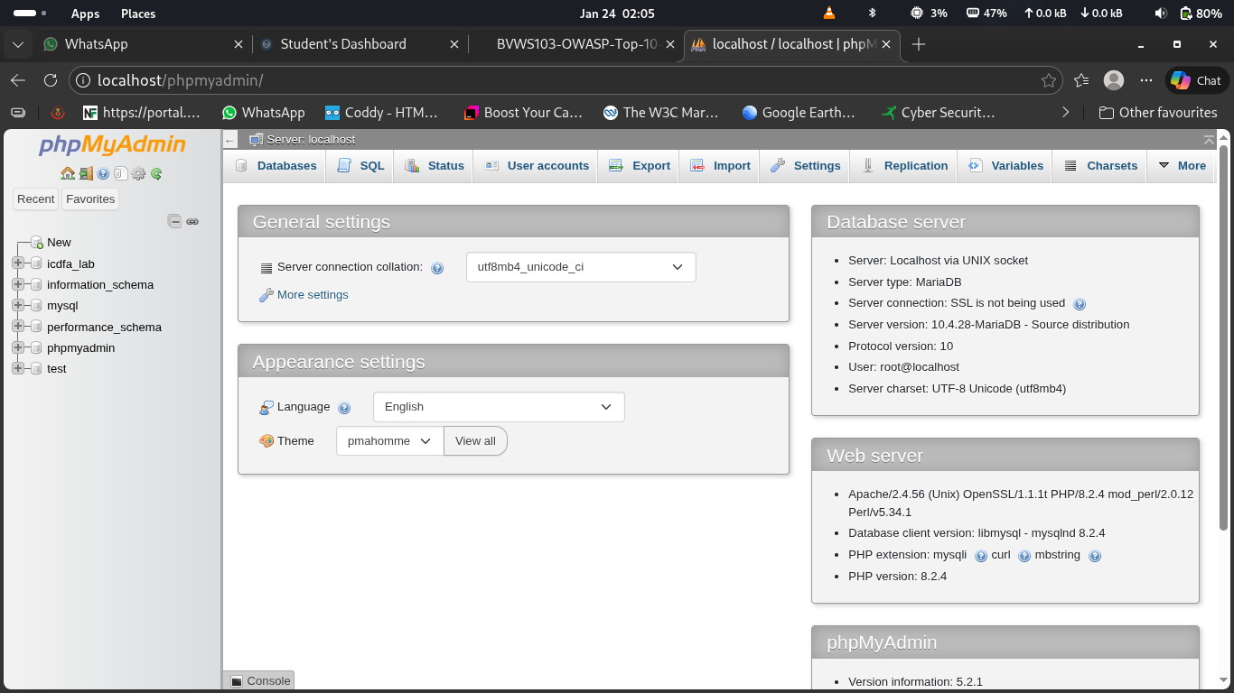

I the creat my database in side and save it

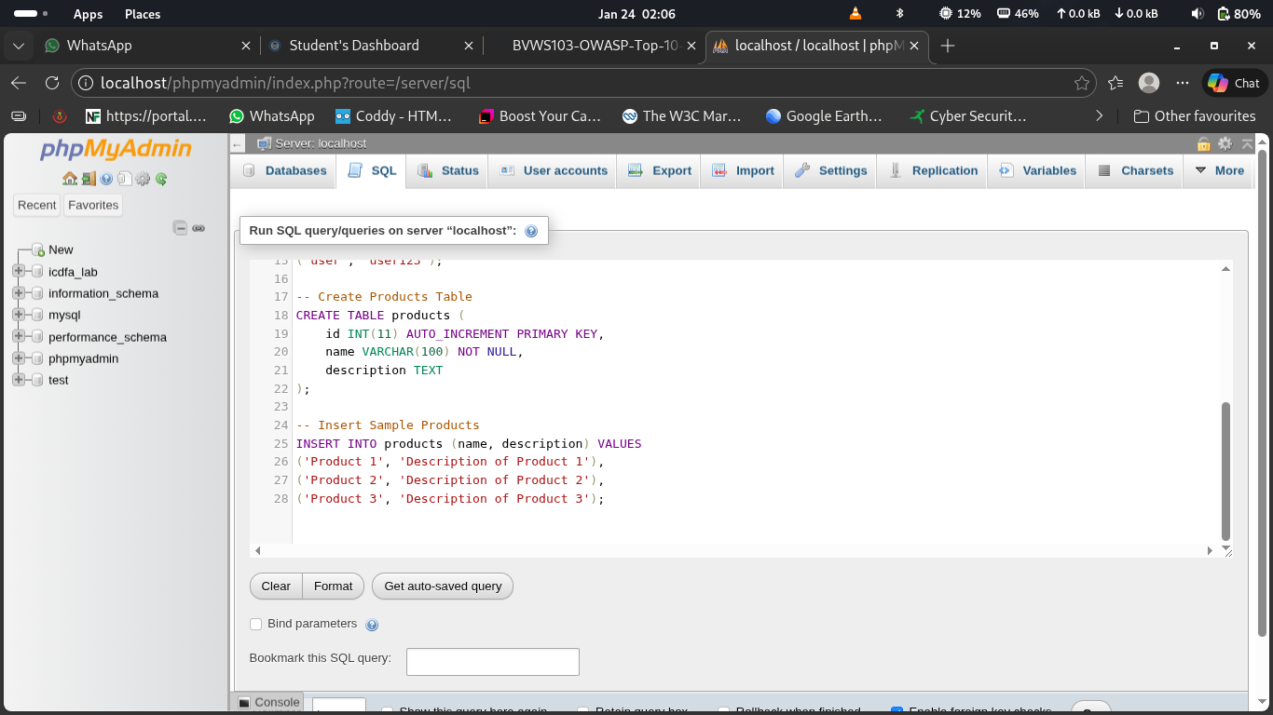

this shows that my database is set successfully

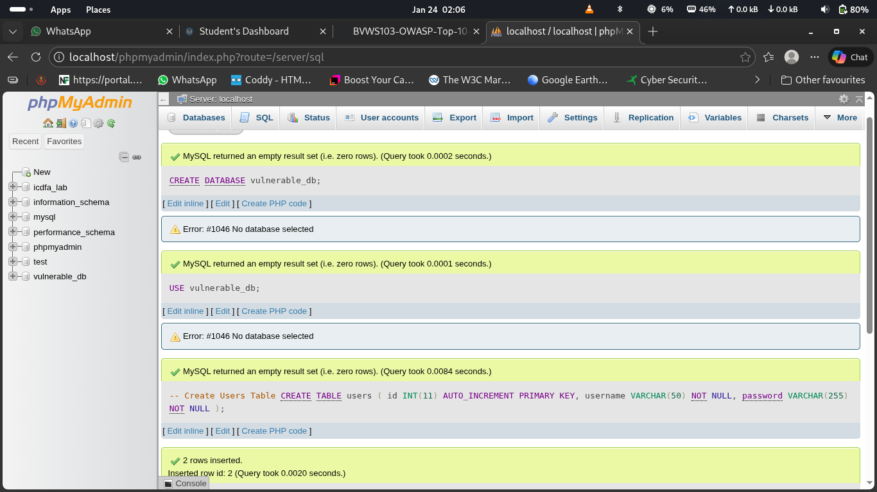

I then move to my terminal to change the permision of the perfect and prefer directory of my database using the command ”sudo chmod 777 opt/lampp/htdocs”

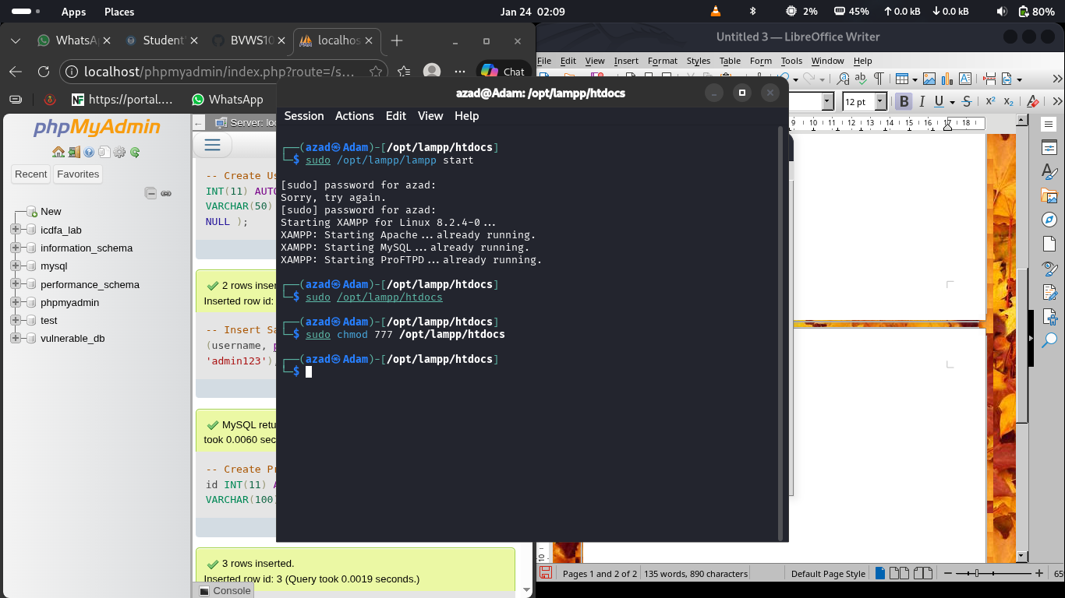

Step 2: Vulnerable Application Code

I then create the a folder for the application and name it Lab1 in the htdocs
Then I create all the application files and write all the perfect codes which include: config.php, db.php, index.php, register.php, login.php and search.php

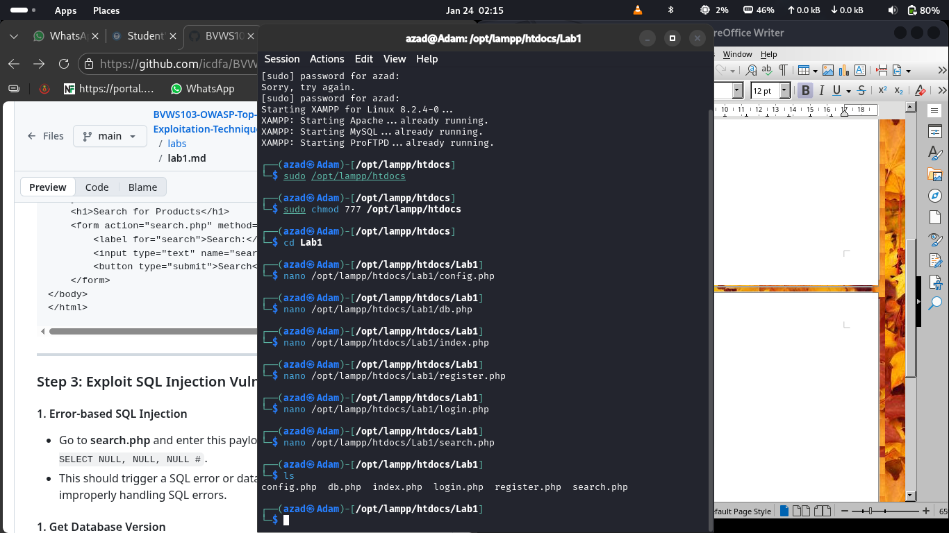

this is the view of the application in my browser (http://localhost/Lap1)

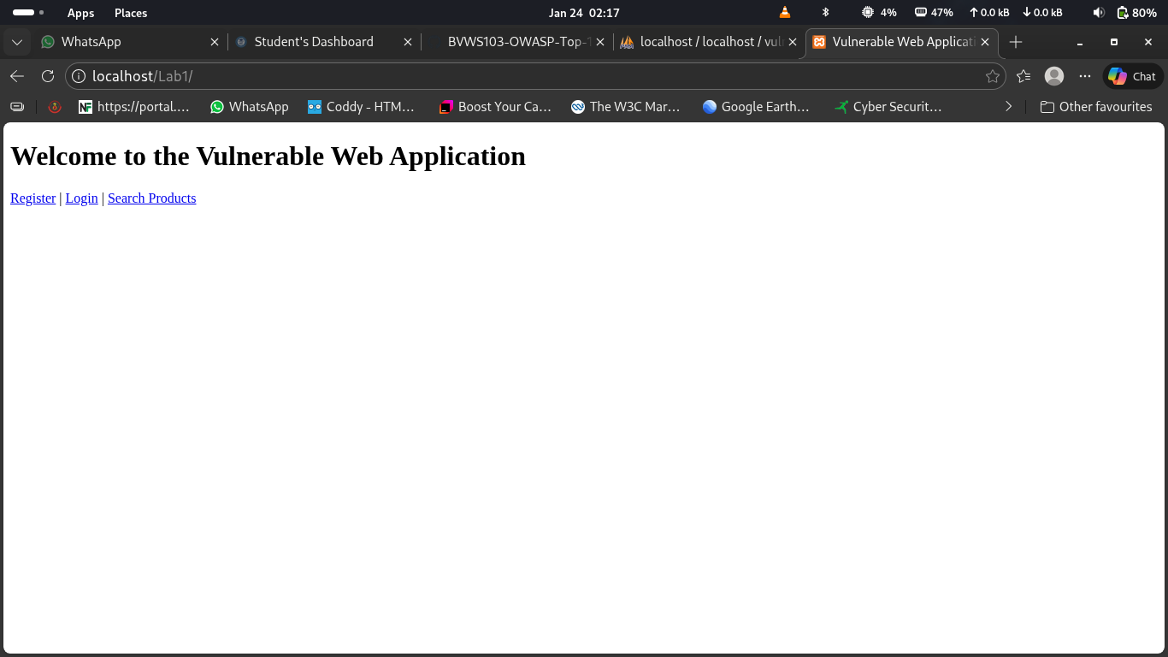

Step 3: Exploit SQL Injection Vulnerabilities
I Go into search.php and enter this payload into the search box: ‘ UNION SELECT NULL, NULL, NULL # to check for sql volnerability

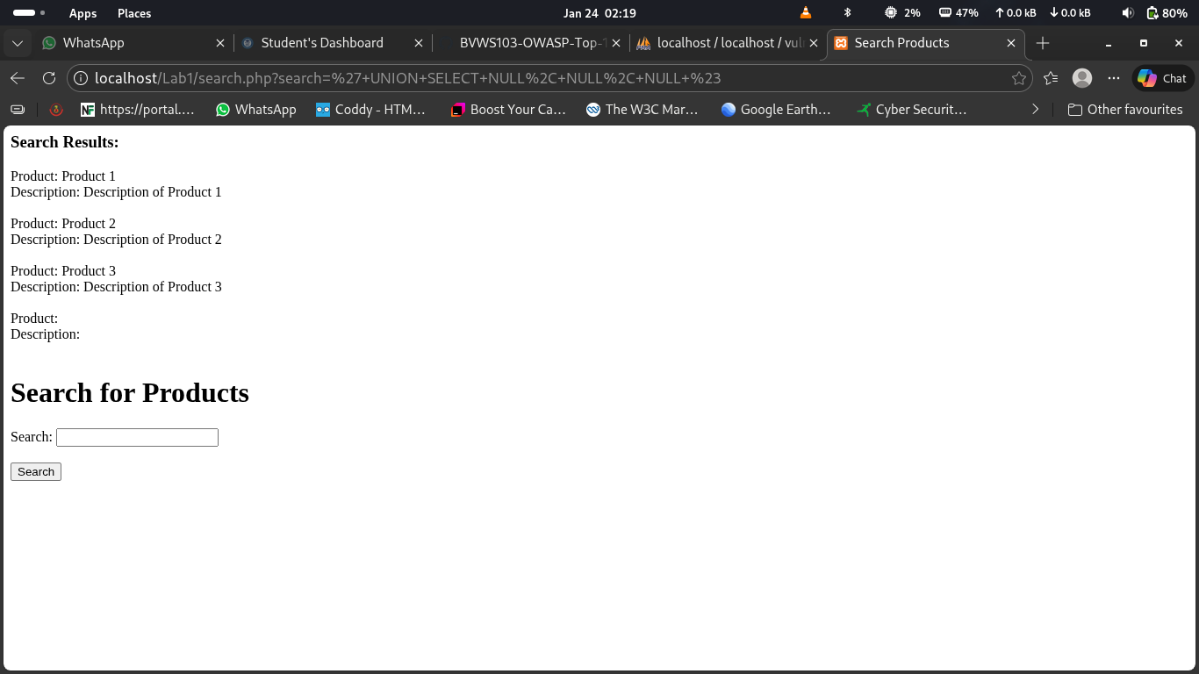

I also retrieve the version of the database by using this payloads 1’ UNION SELECT NULL, version(), NULL #

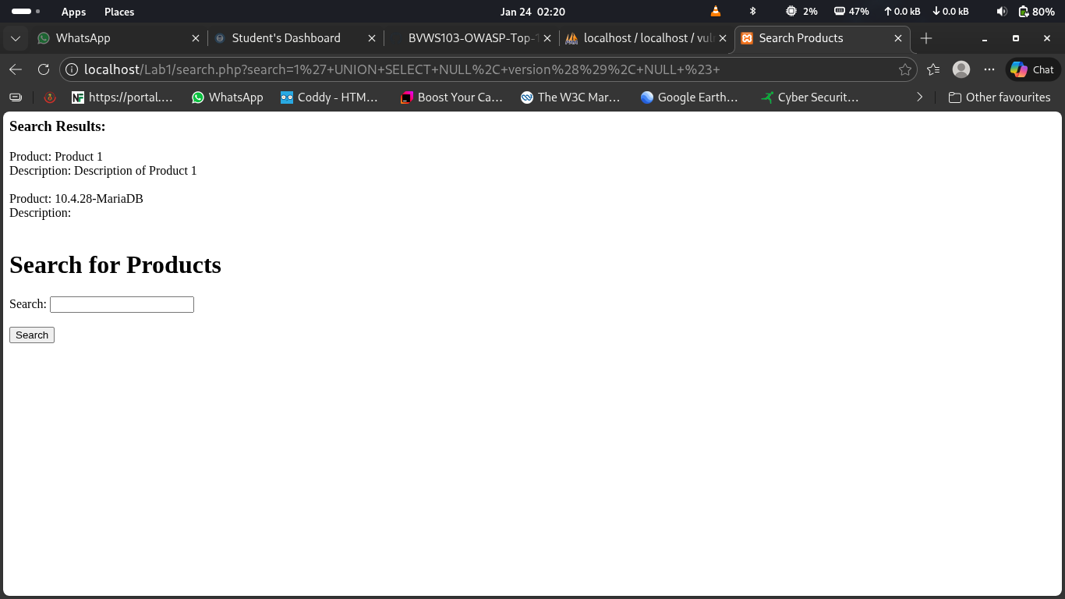

I retrieve the name of the current database using 1’ UNION SELECT NULL, database(), NULL #

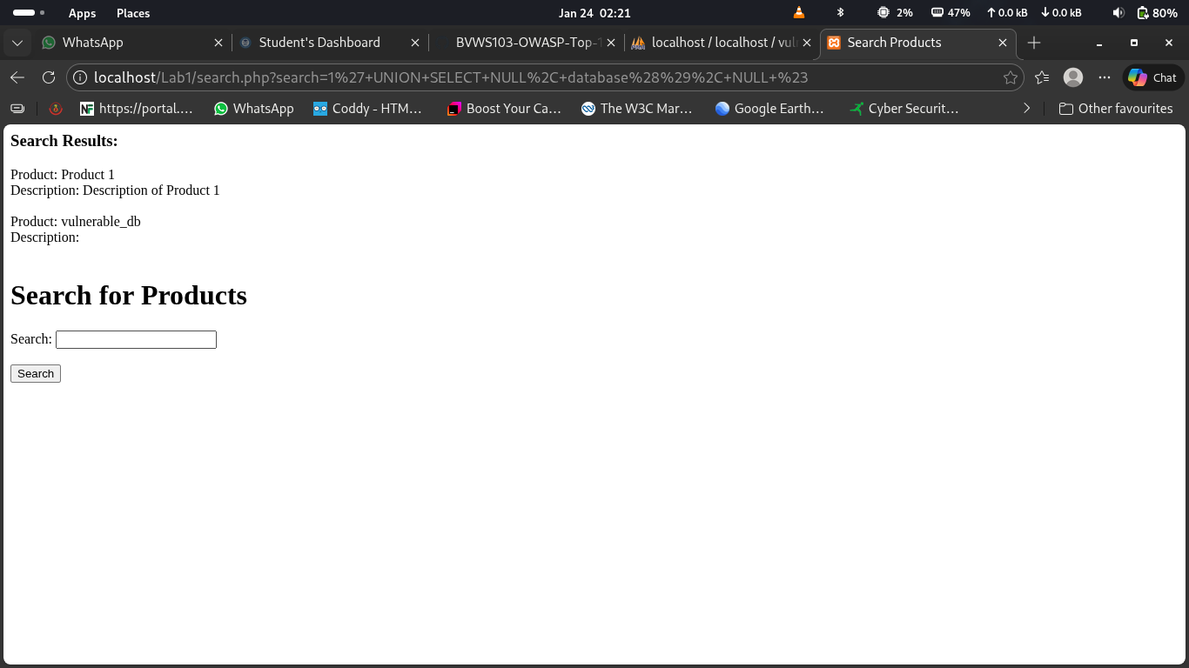

and get the current user connected to the database. Using 1’ UNION SELECT NULL, user(), NULL #

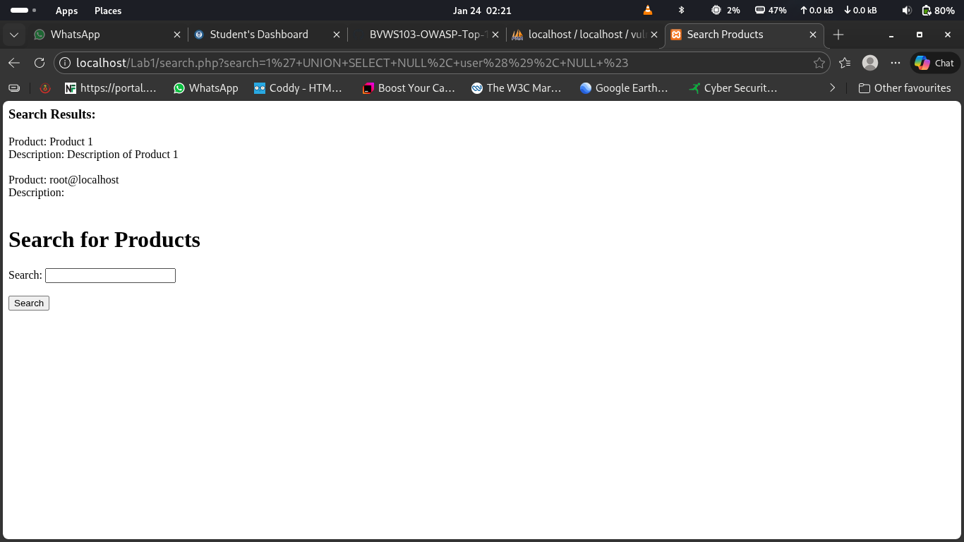

I always modify my payloads before injecting it into any webapp to avoid distraction

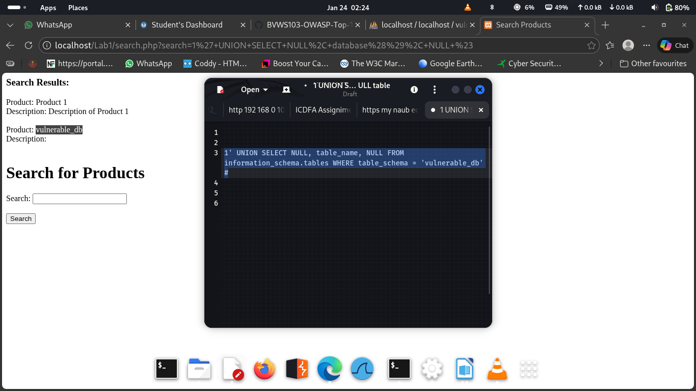

I review all table names from the database and i found only 2 tables

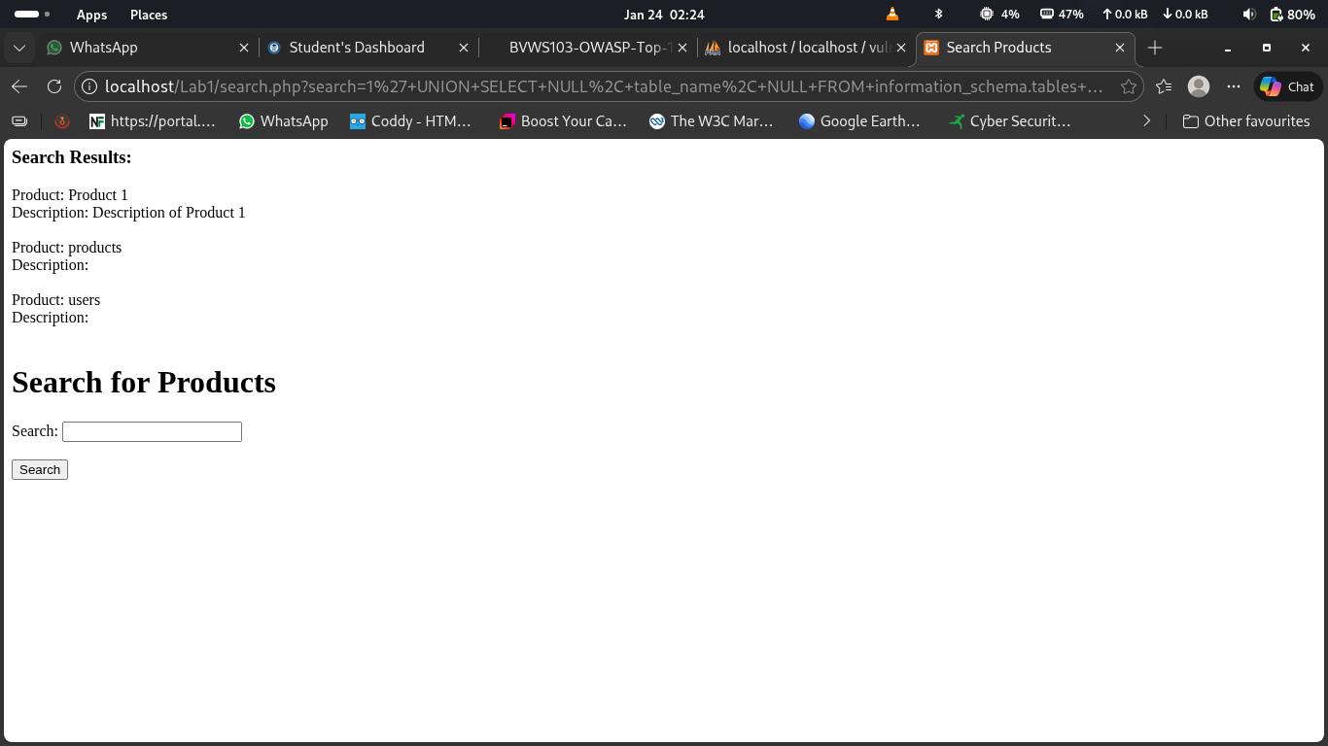

This is the list of all the column fron the users table

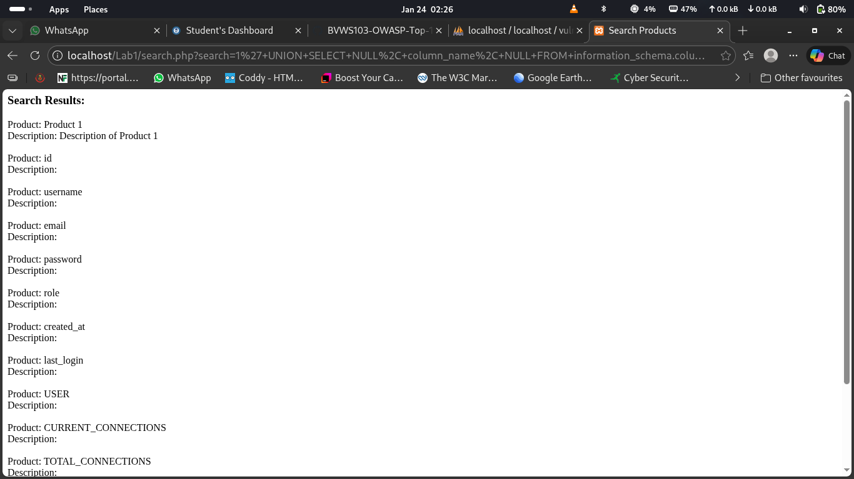

these are the password saved in the column password inside the table users which I found

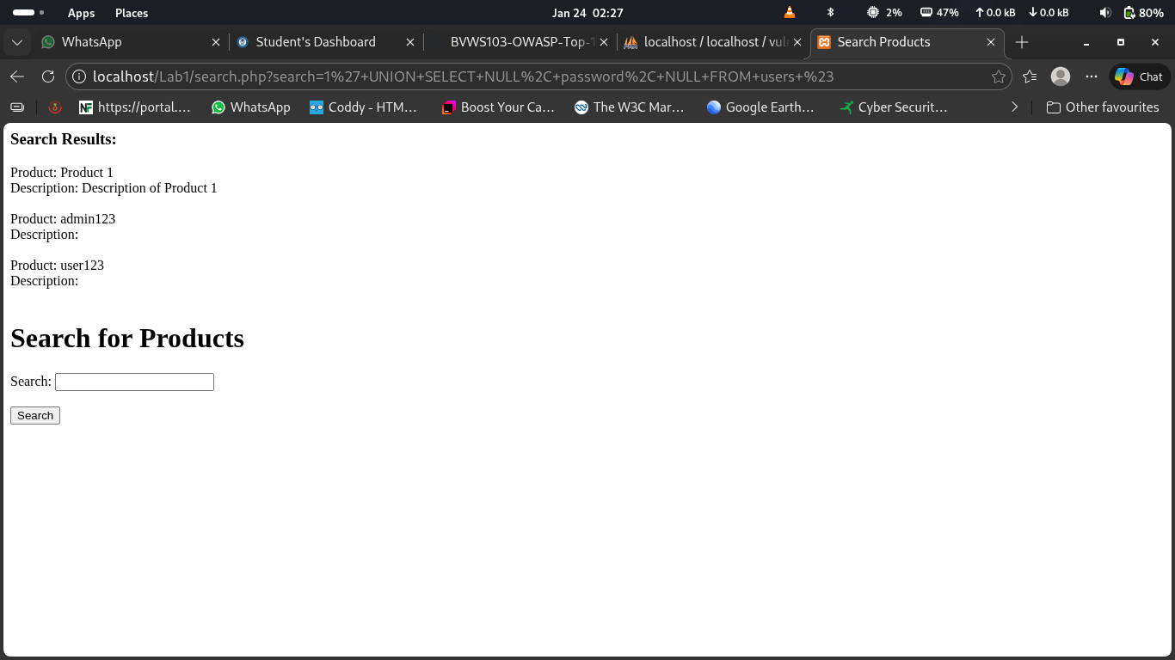

Scenario 7: Read File from the Server
After SQL injection is successful i try to read a file from the server using load_file and this work successful
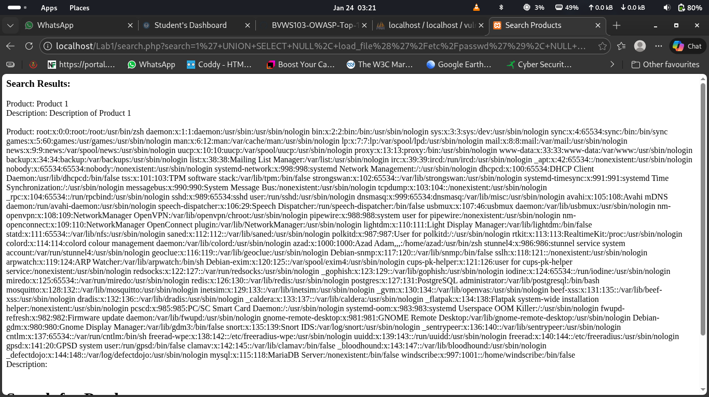

cenario 8: Write Data to a File on the Server
After confirming SQL injection used I also write malicious content to a file on the server that will be pasted in the databe and i can also use that to explore a webapplication and control the server remotely all are
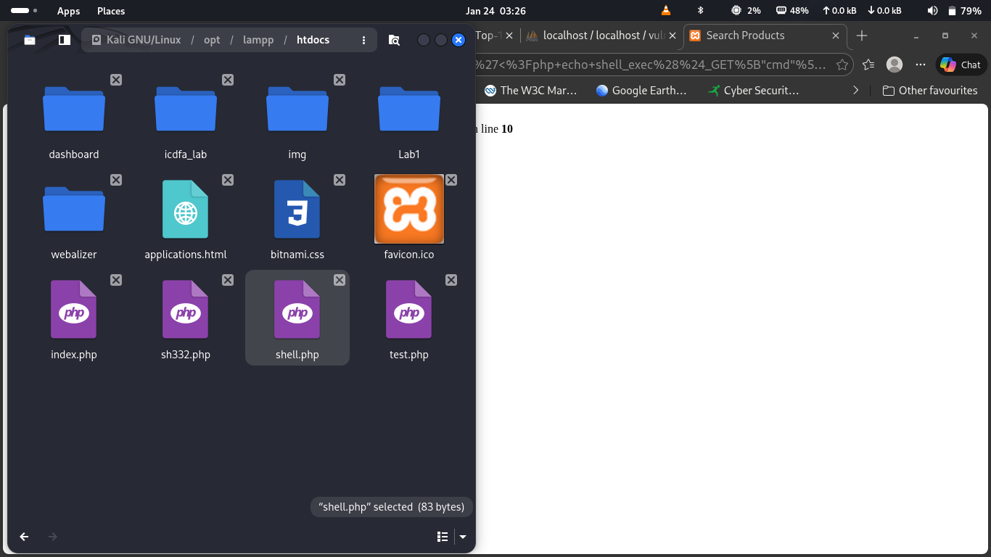

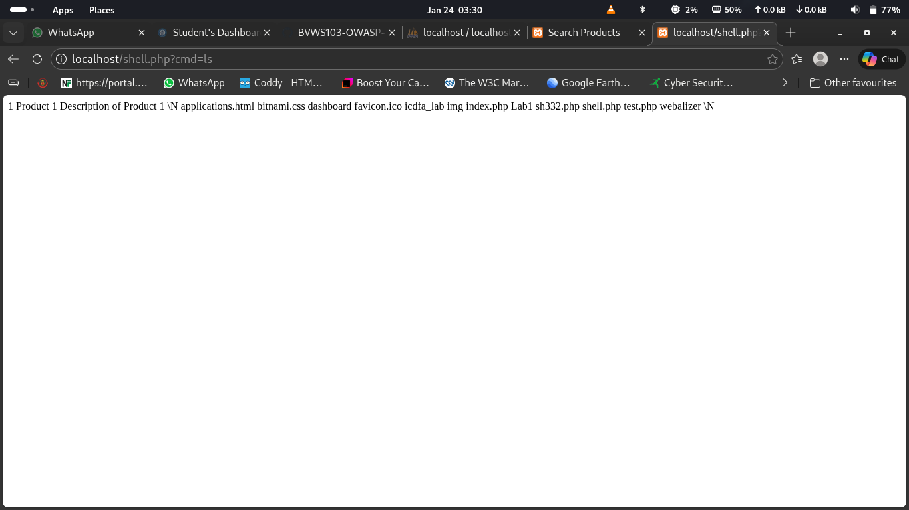

9. Trigger Column Mismatch (Error Handling Test)
This actualy does not change anythin or perform any action that how the error is been handle

10. List All Tables in All Databases
Retrieve all table names from all databases exploiting information schema

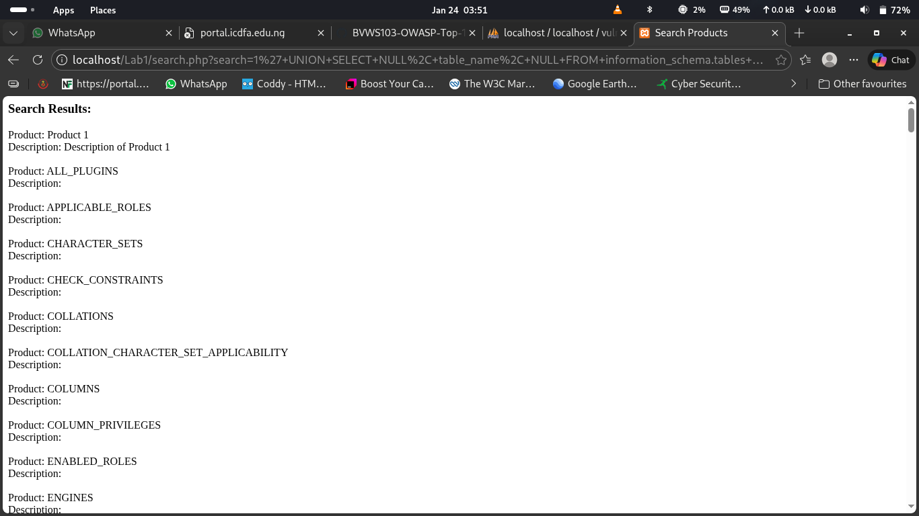

11. List All Columns in All Tables
Retrieve all column names from all tables in the database.

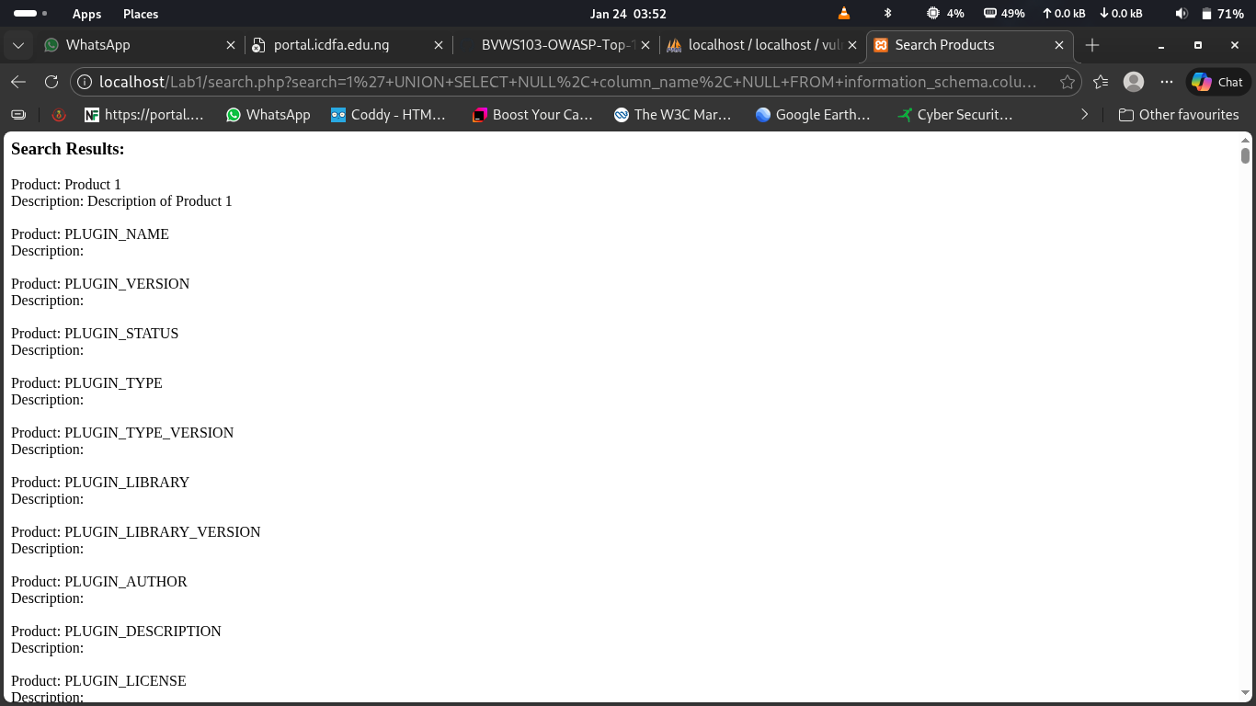

12. Search for Sensitive Data (e.g., Password Columns)
This are retrieve columns containing sensitive passwords

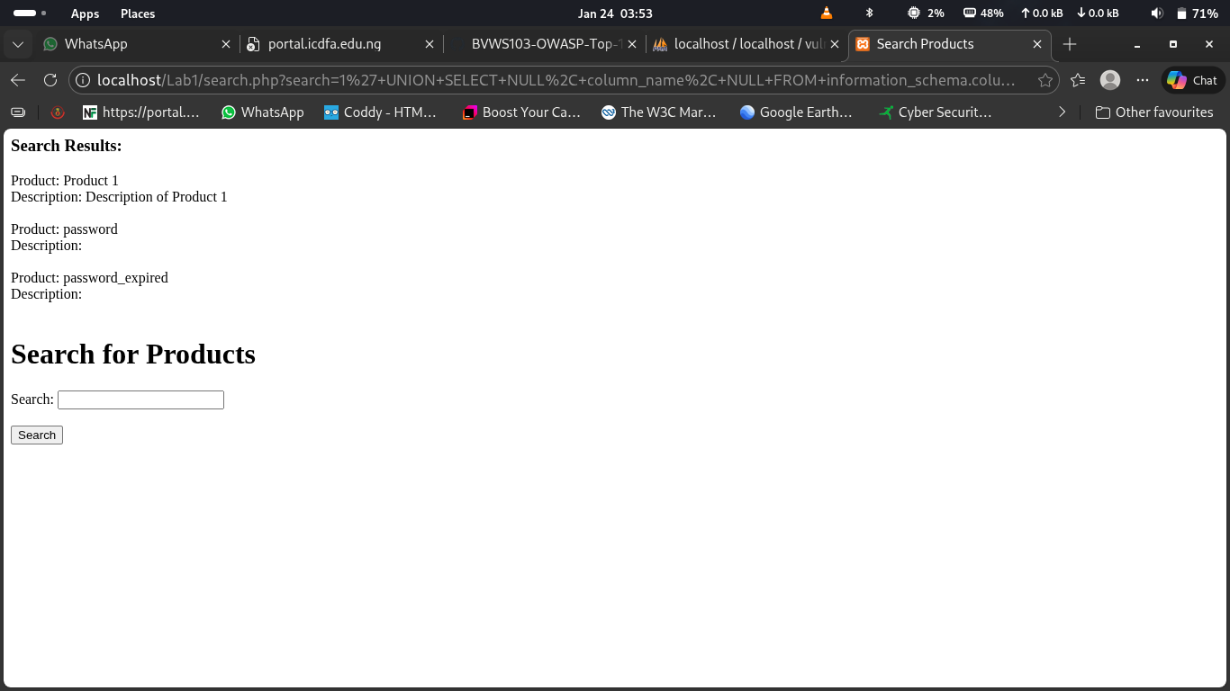

14. Count the Rows in a Table
Retrieve the number of rows in a specific table.

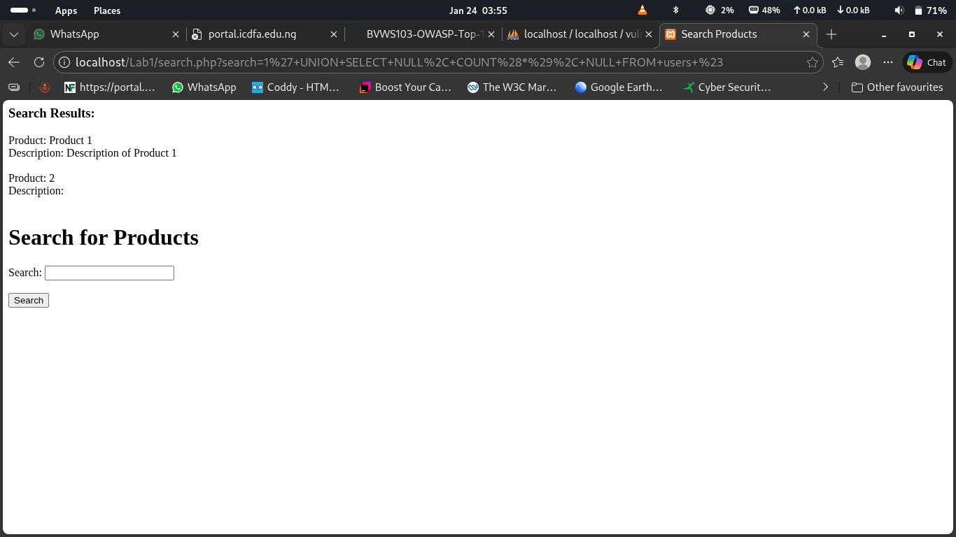

15. Retrieve the Current Date
Retrieve the current date from the database.

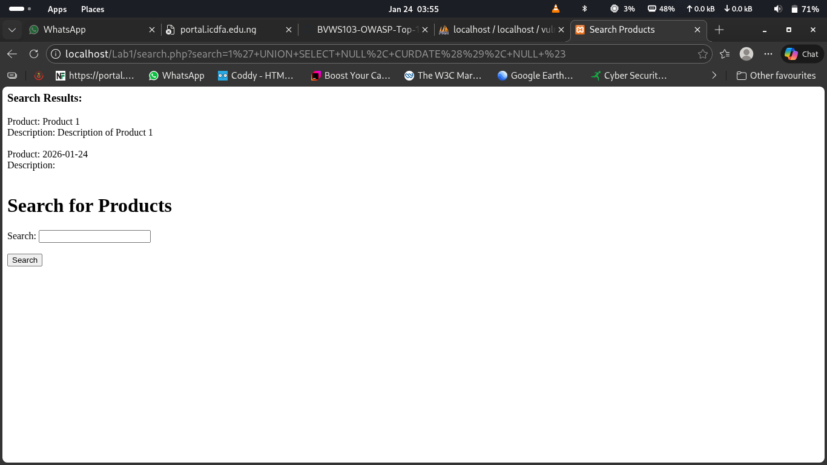

16. Perform Time-Based Blind SQL Injection
Test for time-based blind SQL injection by introducing a delay.
This acctually maks a delay

17. Retrieve Database System Information
Retrieve detailed database system information
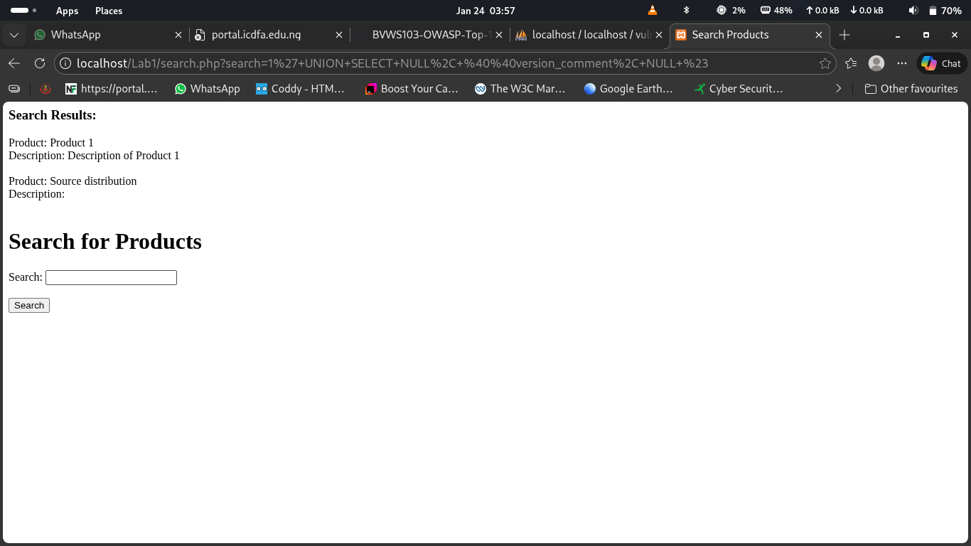

18. Retrieve Schema Information
Retrieve schema information from the database.
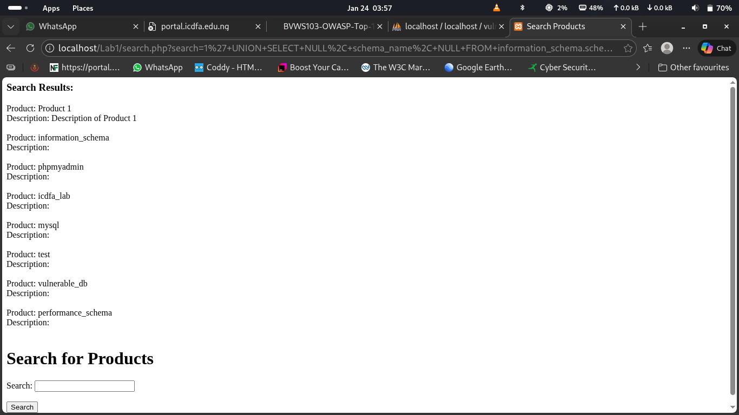

19. Trigger Error-Based SQL Injection
Generate an error to reveal database structure via error messages.
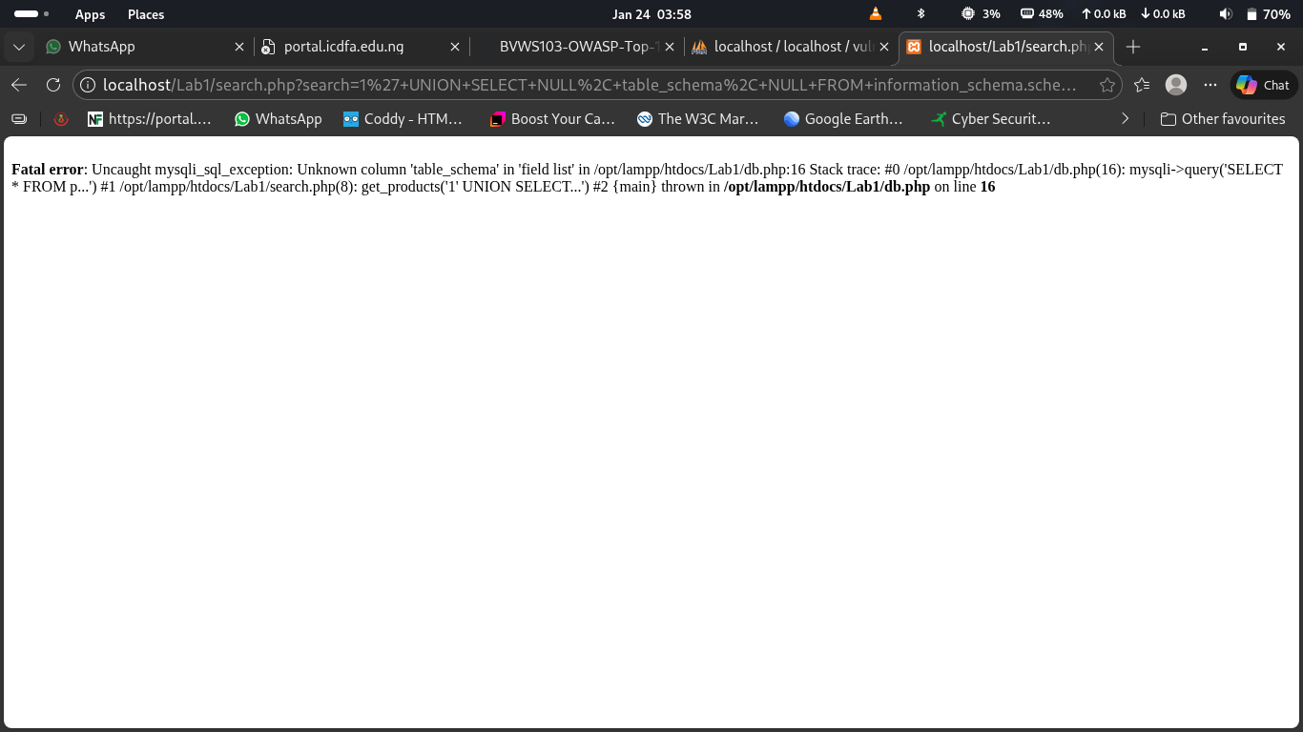

20. Extract Hostname or System Information
Objective: Retrieve system-level information such as the database hostname.

